String formatting in python
String formatting can be done in python using the format method.
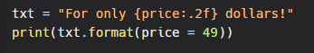
f-strings in python
It is a new string formatting mechanism introduced by the PEP 498. It is also known as Literal String Interpolation or more commonly as F-strings (f character preceding the string literal). The primary focus of this mechanism is to make the interpolation easier.
When we prefix the string with the letter 'f', the string becomes the f-string itself. The f-string can be formatted in much same as the str.format() method. The f-string offers a convenient way to embed Python expression inside string literals for formatting.
Example
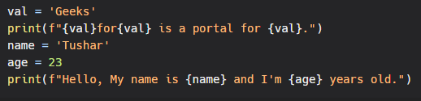
Output:
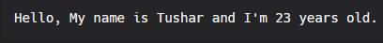
In the above code, we have used the f-string to format the string. It evaluates at runtime; we can put all valid Python expressions in them.
We can use it in a single statement as well.
Example
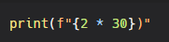
Output:
60

